**### Task 1: Create a GPO: Disable Local Link Multicast Name Resolution (LLMNR)**

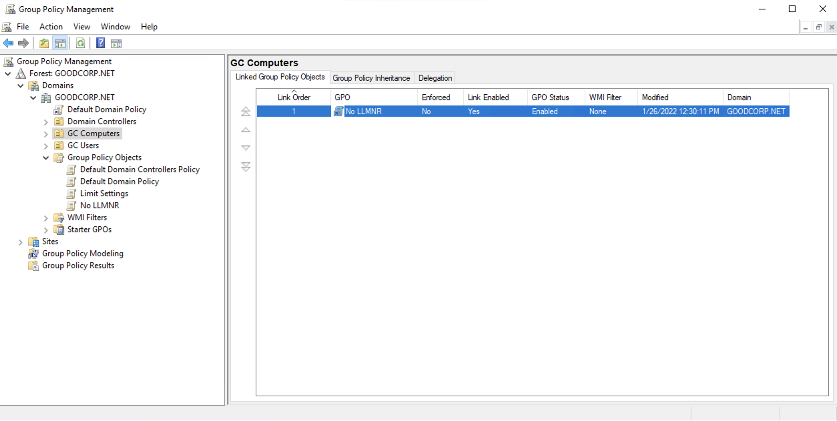

**### Task 2: Create a GPO: Account Lockout**

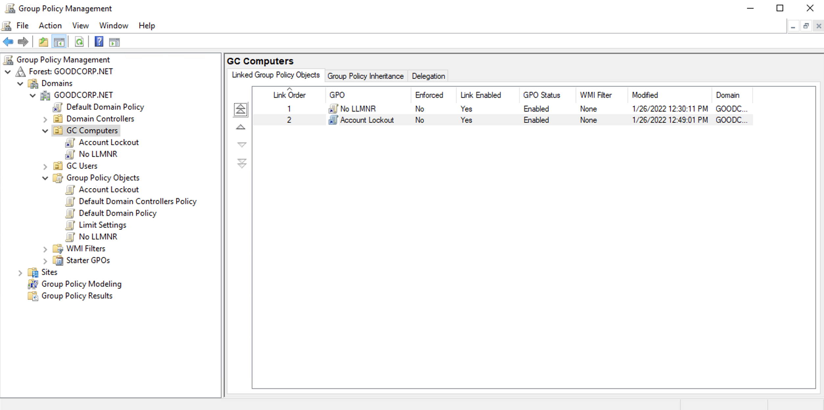

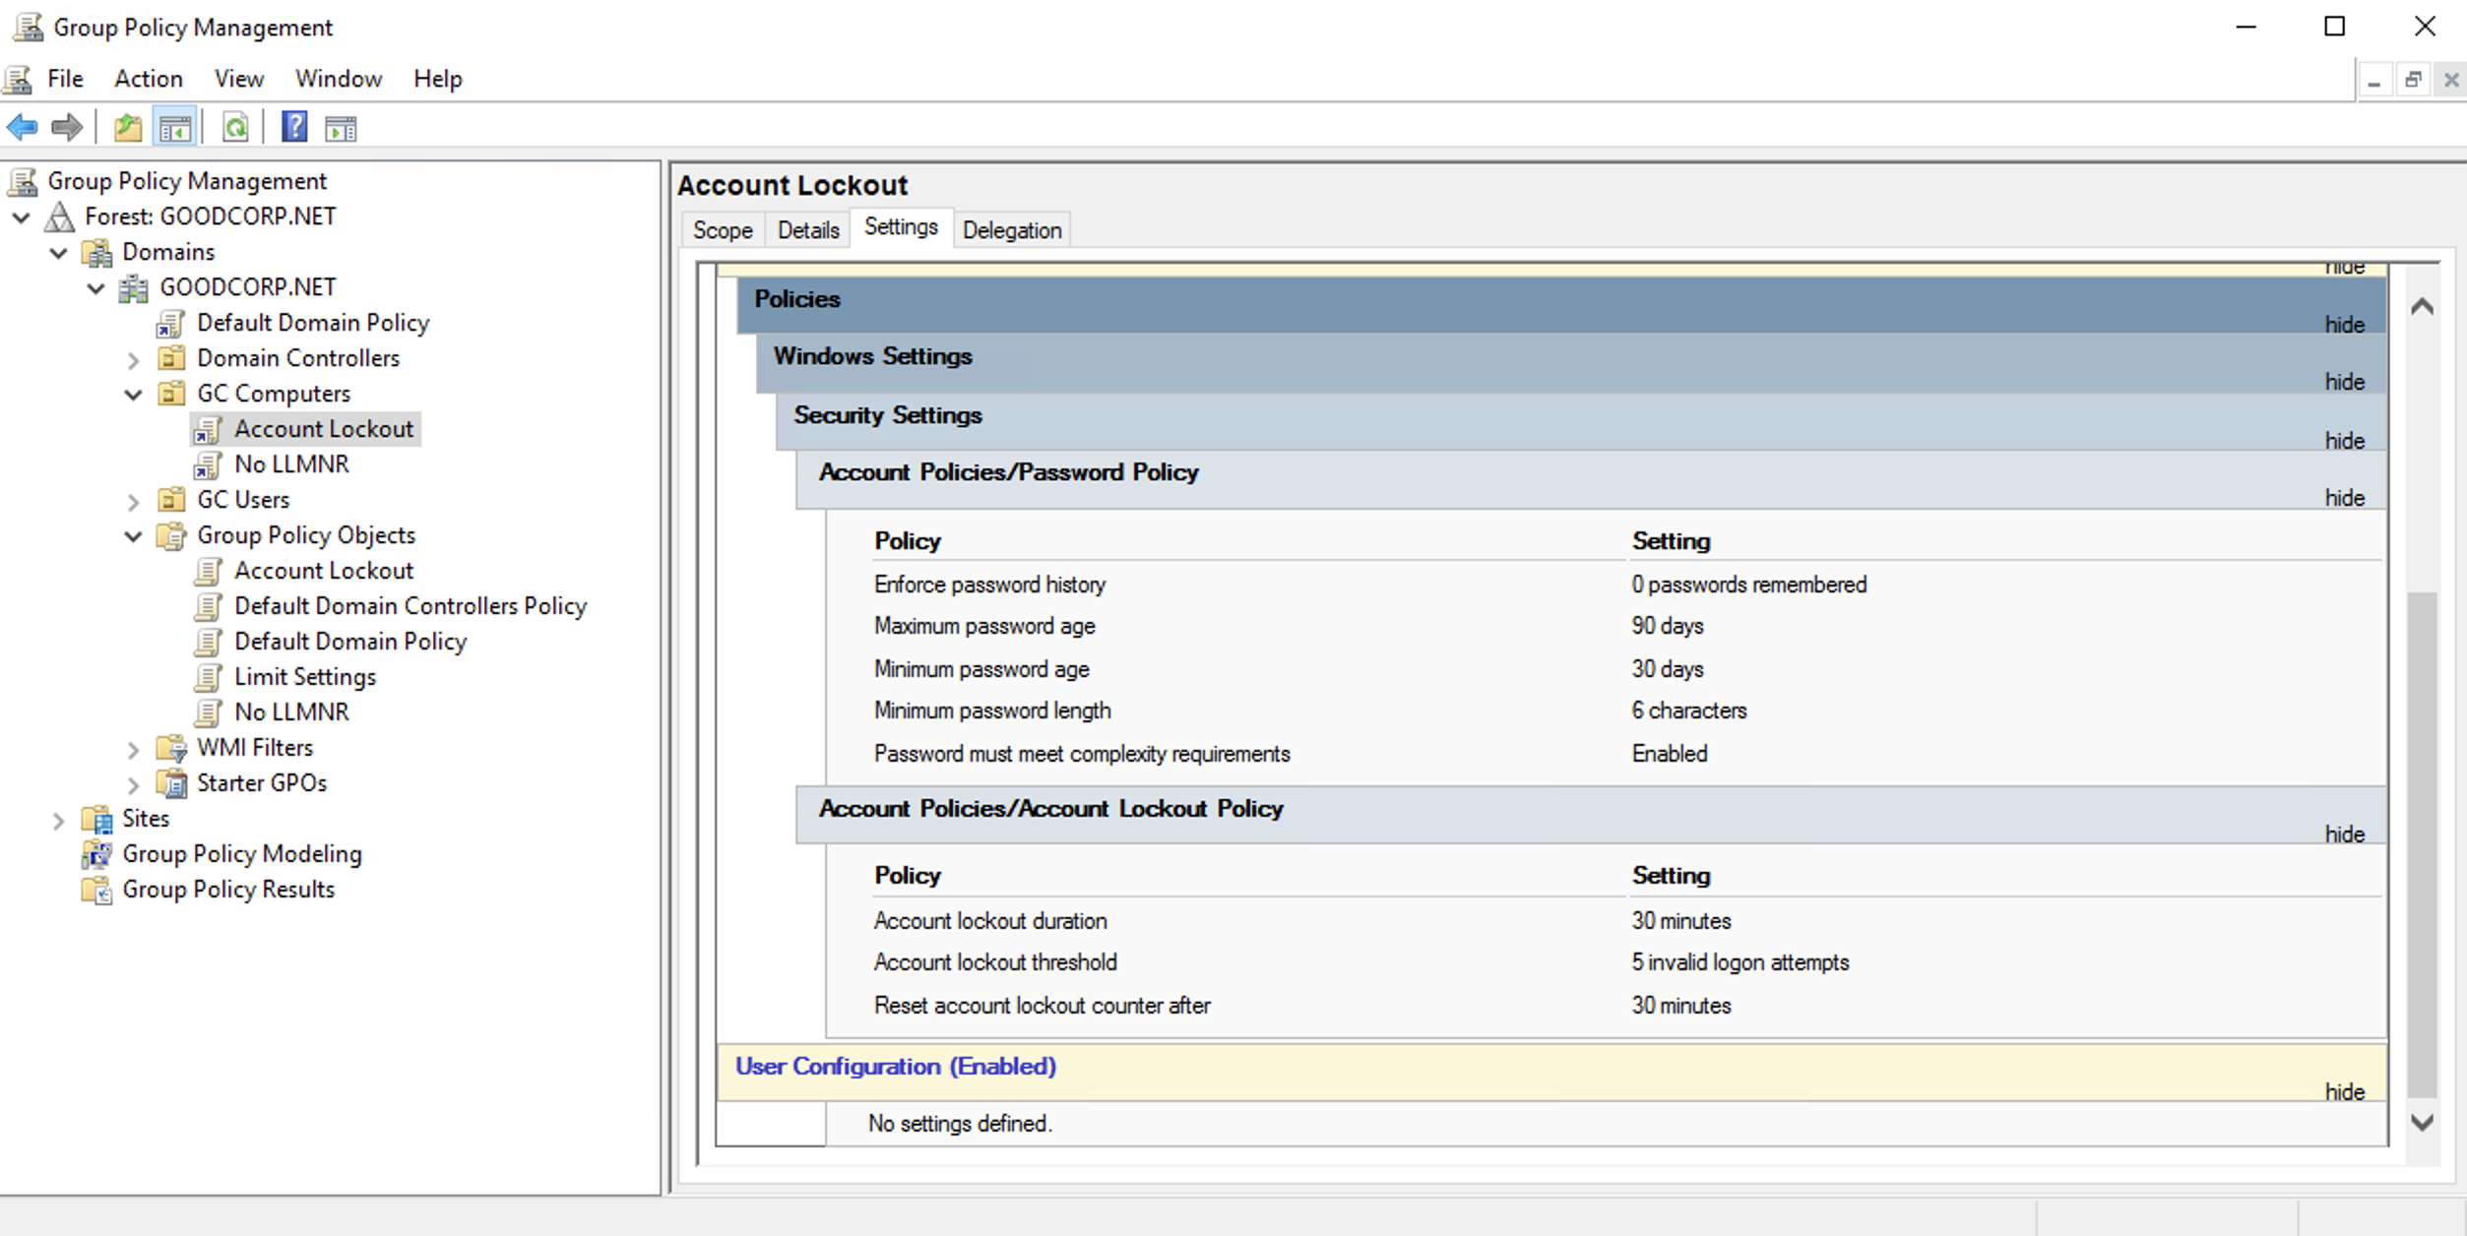

**### Task 3: Create a GPO: Enabling Verbose PowerShell Logging and Transcription**

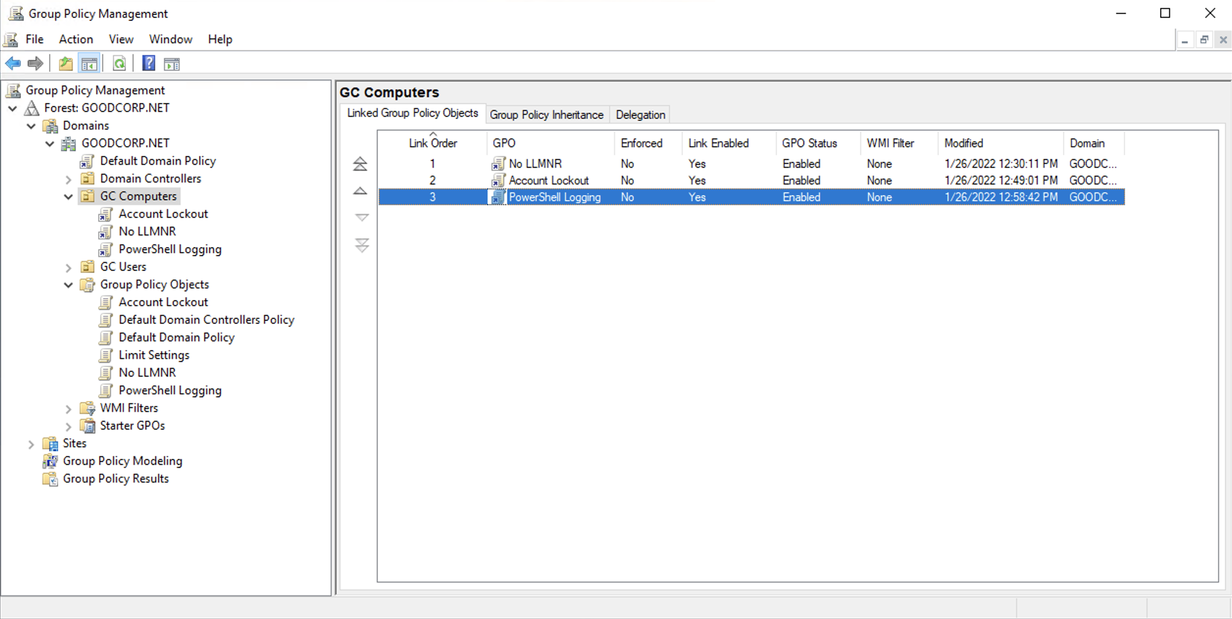

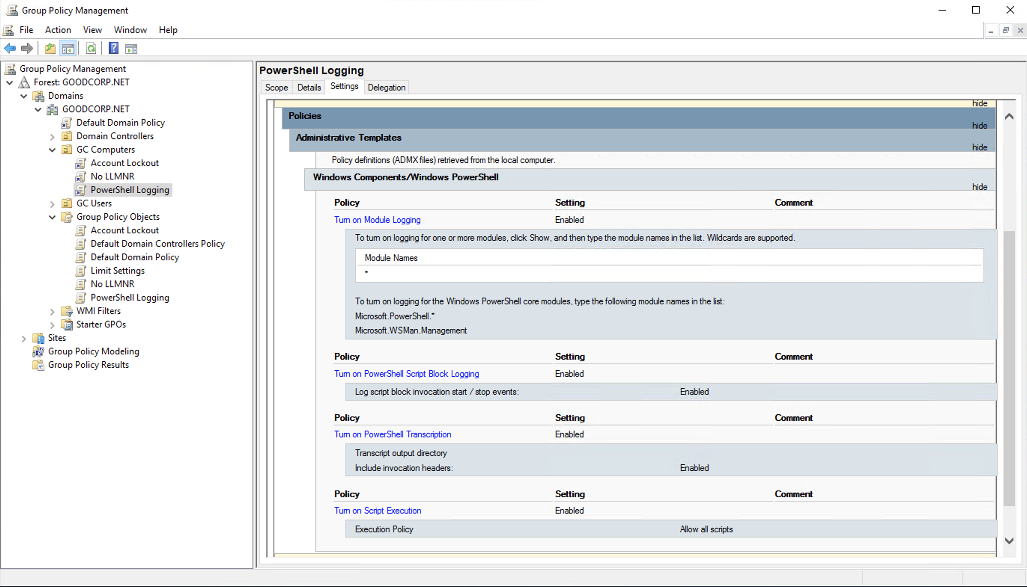

**### Task 4: Create a Script: Enumerate Access Control Lists**

$directory = Get-ChildItem .\

foreach ($item in $directory) {

Get-Acl $item

}

**### Bonus Task 5: Verify Your PowerShell Logging GPO**

